Assignment 4

My Instagram ID is narmada 35298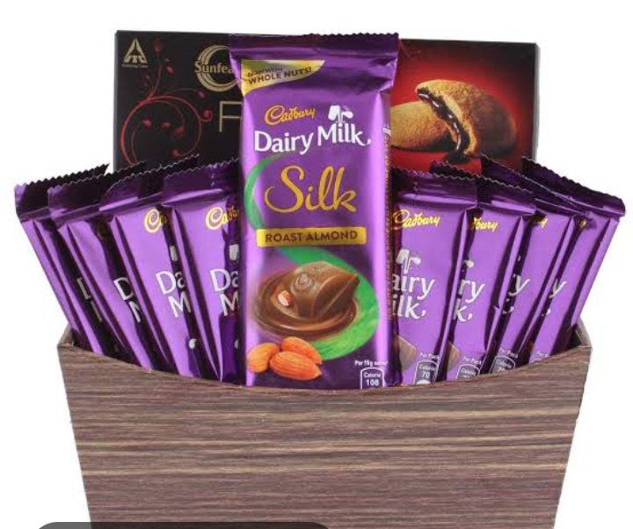

Here is my Instagram link 👇

Link:<https://instagram.com/stories/narmada35298/3208214549257713101?utm_source=ig_story_item_share&igshid=ODk2MDJkZDc2Zg==>